**BETA TESTING:**

**QUICK FTSS VERSION 2.0 INTERFACE INSTRUCTION/INSTALLATION GUIDES**

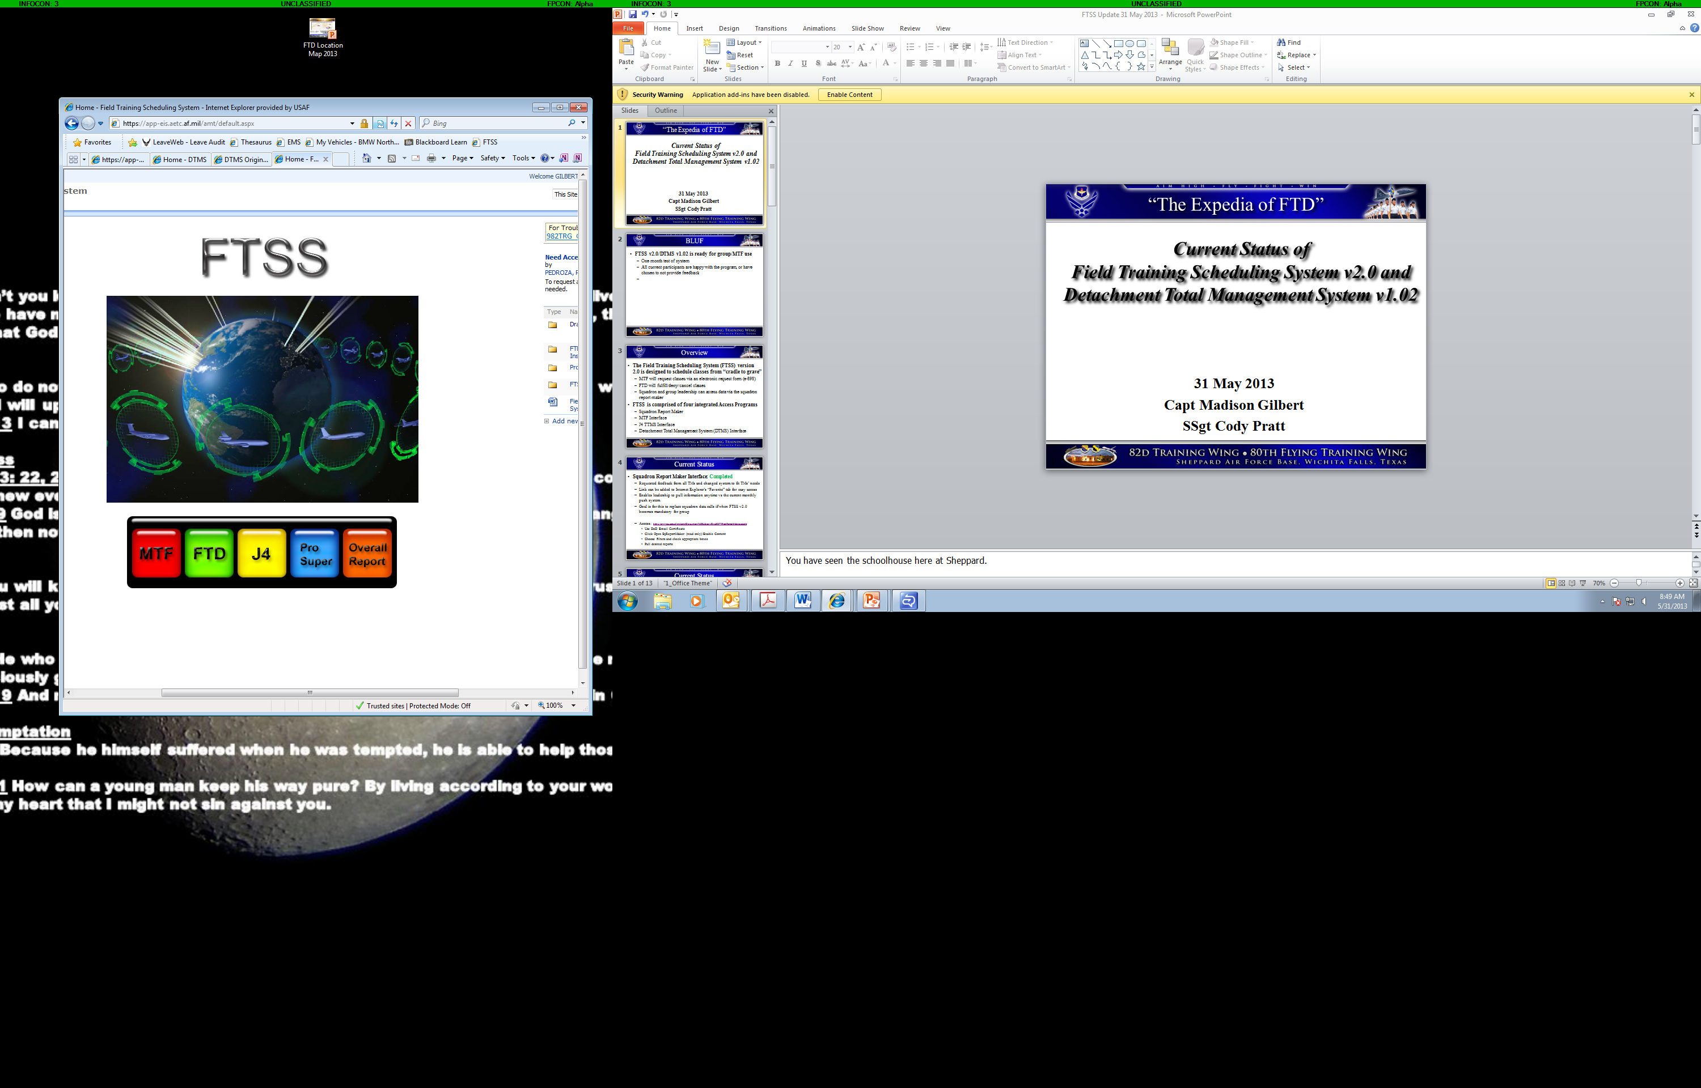

**Table of Contents:**

*Please look at the Interface Instructions for the interface that applies to your job*

*(i.e. if you are in MTF, please go to page 2; if you are in FTD, please go to page 5)*

MTF FTSS Interface………………………………………………..……………………….2

Squadron Production Report Maker FTSS Interface………………..………………………3

J4 TTMS Assigner FTSS Interface..……………………………………….………………..4

FTD FTSS Interface OR DTMS FTSS Interface……………………………………………5

**MTF Interface**

Click on the following Link:

<https://app-eis.aetc.af.mil/amt/Document%20Library/Draft/MTFInterface.accdb>

1. Use CAC DOD Email certificate (must select email certificate)
2. Click on Open MTF FTSS Interface
3. Select Read Only
4. Select the Enable Content button
5. Use

If you do not have access to the interface or to FTSS, you will need to send an email to [982TRG_CCK@sheppard.af.mil](mailto:982TRG_CCK@sheppard.af.mil) requesting access to FTSS. Include that you are a MTF Scheduler and need access to the MTF tab.

For a step-by-step instructional guide to the MTF interface, click on the following link, select the EMAIL certificate, and then select “MTF_Interface_HowTo”

* <https://app-eis.aetc.af.mil/amt/Document%20Library/Forms/AllItems.aspx?RootFolder=https%3a%2f%2fapp%2deis%2eaetc%2eaf%2emil%2famt%2fDocument%20Library%2fDraft&FolderCTID=0x0120005C3C0273B7BD2E48942076BCA3FE9F90>

Having a shortcut in your favorites to the interface is the best method to ensure you are always using the most current version.

To add a shortcut to your favorites:

* Open Internet Explorer
* Paste the following link into the URL: <https://app-eis.aetc.af.mil/amt/Document%20Library/Forms/AllItems.aspx?RootFolder=https%3a%2f%2fapp%2deis%2eaetc%2eaf%2emil%2famt%2fDocument%20Library%2fDraft&FolderCTID=0x0120005C3C0273B7BD2E48942076BCA3FE9F90>
* Click the Star icon with the Green Arrow pointing to the right
* The link will be saved as Document Library
  + To save it as a different title (say “MTF Interface”), right Click the Document Library, click rename, and add the new name
* You may now click on this tab to go to the Document Library, then must click MTFInterface to access the MTF Interface

**Squadron Production Report Maker Interface**

Click on the following Link:

<https://app-eis.aetc.af.mil/amt/Document%20Library/Draft/SqProdReportMaker.accdb>

1. Use CAC Email certificate (must select email certificate)
2. Click on Open SQProdReportMaker
3. Select Read Only
4. Select the Enable Content button
5. Use

If you do not have access to the interface or to FTSS, you will need to send an email to [982TRG_CCK@sheppard.af.mil](mailto:982TRG_CCK@sheppard.af.mil) requesting access to FTSS. Include the reason you need access and which functions you need access to (MTF, FTD, J4, ProSuper, and/or Overall Report).

For a step-by-step instructional guide to the Squadron Production Report Maker, click on the following link and select “Sq_ProdReportMaker_HowTo”

<https://app-eis.aetc.af.mil/amt/Document%20Library/Forms/AllItems.aspx?RootFolder=https%3a%2f%2fapp%2deis%2eaetc%2eaf%2emil%2famt%2fDocument%20Library%2fDraft&FolderCTID=0x0120005C3C0273B7BD2E48942076BCA3FE9F90>

Having a shortcut in your favorites to the interface is the best method to ensure you are always using the most current version.

To add a shortcut to your favorites:

* Open Internet Explorer
* Paste the following link into the URL: <https://app-eis.aetc.af.mil/amt/Document%20Library/Forms/AllItems.aspx?RootFolder=https%3a%2f%2fapp%2deis%2eaetc%2eaf%2emil%2famt%2fDocument%20Library%2fDraft&FolderCTID=0x0120005C3C0273B7BD2E48942076BCA3FE9F90>
* Click the Star icon with the Green Arrow pointing to the right
* The link will be saved as Document Library
  + To save it as a different title (say “Sq Prod Report Maker”), right Click the Document Library, click rename, and add the new name
* You may now click on this tab to go to the Document Library, then must click SqProdReportMaker to access the Squadron Production Report Maker

**J4 TTMS Assigner Interface**

Click on the following Link:

<https://app-eis.aetc.af.mil/amt/Document%20Library/Draft/J4TTMSAssigner.accdb>

1. Use CAC Email certificate (must select email certificate)
2. Click on Open J4TTMSAssigner
3. Select Read Only
4. Enable Content (select the yellow Enable Content button)
5. Use

If you do not have access to the interface or to FTSS, you will need to send an email to [982TRG_CCK@sheppard.af.mil](mailto:982TRG_CCK@sheppard.af.mil) requesting access to FTSS. Include that you are a J4 Scheduler and need access to the J4 Button.

Having a shortcut in your favorites to the interface is the best method to ensure you are always using the most current version.

To add a shortcut to your favorites:

* Open Internet Explorer
* Paste the following link into the URL: <https://app-eis.aetc.af.mil/amt/Document%20Library/Forms/AllItems.aspx?RootFolder=https%3a%2f%2fapp%2deis%2eaetc%2eaf%2emil%2famt%2fDocument%20Library%2fDraft&FolderCTID=0x0120005C3C0273B7BD2E48942076BCA3FE9F90>
* Click the Star icon with the Green Arrow pointing to the right
* The link will be saved as Document Library
  + To save it as a different title (say “J4 TTMS Assigner”), right Click the Document Library, click rename, and add the new name
* You may now click on this tab to go to the Document Library, then must click J4TTMSAssigner to access the J4 Interface

For a step-by-step instructional guide to the J4 TTMS Assigner, click on the following link and select “J4_TTMSAssigner_HowTo”

* <https://app-eis.aetc.af.mil/amt/Document%20Library/Forms/AllItems.aspx?RootFolder=https%3a%2f%2fapp%2deis%2eaetc%2eaf%2emil%2famt%2fDocument%20Library%2fDraft&FolderCTID=0x0120005C3C0273B7BD2E48942076BCA3FE9F90>

**FTD Interface OR Detachment Total Management System (DTMS) Interface**

FTDs have the option of using one of two interfaces to complete the electronic form 898 process: the detachments can use the FTD FTSS Interface OR the Detachment Total Management System Interface

* Detachments must pick only one interface to use
* Both interfaces collate and calculate local level numbers for production and upload directly to FTSS
* Both interfaces interact with FTSS for the electronic Form 898 process and the scheduling of classes at Sheppard AFB after the electronic Form 898 process is complete (to obtain TTMS Class Numbers)

DIFFERENCES: The FTD Interface is solely a scheduling/production system, and requires far less input for a detachment to start utilizing it. DTMS Interface is a full-featured detachment supervision management system which includes the scheduling/production system as well as tracking capabilities for EPRs, Decorations, PT scores/test dates, course qualifications, 281s, etc.

If you do not have access to FTSS, you will need to send an email to [982TRG_CCK@sheppard.af.mil](mailto:982TRG_CCK@sheppard.af.mil) requesting access to FTSS in order to gain access to the interface as well. Include that you are a Production Scheduler/Supervisor and need access to the FTD button (and the ProSuper and Overall Report buttons, if applicable).

For a step-by-step instructional guide to the FTD FTSS Interface or the DTMS FTSS Interface, click on the following link and select “FTD_Interface_HowTo” or “DTMS_Interface_HowTo”:

* <https://app-eis.aetc.af.mil/amt/Document%20Library/Forms/AllItems.aspx?RootFolder=https%3a%2f%2fapp%2deis%2eaetc%2eaf%2emil%2famt%2fDocument%20Library%2fDraft&FolderCTID=0x0120005C3C0273B7BD2E48942076BCA3FE9F90>
* For more help with these interfaces, visit: <https://sheppard.eis.aetc.af.mil/982TRG/dtms/default.aspx>

To start downloading the interfaces, go to one of the following links:

* For the FTD Interface:

<https://sheppard.eis.aetc.af.mil/982TRG/dtms/FTD%20FTSS%20Interace/Forms/AllItems.aspx>

* For the DTMS Interface:

<https://sheppard.eis.aetc.af.mil/982TRG/dtms/DTMS%20Files/Forms/AllItems.aspx>